*Portarlington Neighbourhood House Inc*



AGM Agenda &

Annual Report 2023-2024

87 Newcombe St PORTARLINGTON Vic 3223

Telephone 5259 2290

Email: [enquiry@portnh.org.au](mailto:enquiry@portnh.org.au)

Website: www.portnh.org.au

ABN: 86078 982 172

# AGM 2024 Agenda

Friday 17th October 2024, 5.00pm in Parkview Room

1. Welcome and note apologies (quorum =20)

3 Minutes for approval

* Minutes of AGM held on 20th October 2023
* Minutes of Special General Meeting held on 19th June 2023

4 Accept financial report for the year ended 30 June 2024

5 Accept annual strategic performance report 2023-24

6 Election of members to the Committee of Management

* President
* Vice-President
* Secretary
* General Committee Members

*[The positions of Treasurer and Assistant Treasurer are CoM appointments]*

7 Recognition of 2024 retiring committee members (President)

8 Meeting close

# Report Contents

AGM 2024 Agenda 1

Report Contents 1

Meet the PNH TEAM 2023-24 2

Financial Report 2023-24 4

Balance Sheet 5

Profit & Loss Statement 6

Summary of profit & loss (operational surplus) 7

Grants, Sponsorship & Donations 8

PNH Strategic Performance 2023-24 9

1 Membership 11

2 Member Activities 12

3 Community Connections 13

4 Culture 14

5 Governance & Adminisration 15

Minutes 16

# Meet the PNH TEAM 2023-24

|  |  |
| --- | --- |
| Committee 2023-4 Margaret Belfrage - President  Geoff McDonald - Treasurer  Jacquie Wissenden - Secretary  Stella McLean -Assistant Treasurer  Mark Chaffers - Risk & Compliance  Jonathan Harris - Quality & Performance  Mary Drew - Document Control  Matt Helme - Strategic Marketing  Vacant - Program Policy Employees Rob Sztogryn - Program Manager  Kate Hayes -Administration Assistant/Communications Office Assistants Annie Bugejar  Carmen Spiteri  Diane Chaffers  Diane Ryan  Jackie Chase  Julie Walker  Katie Hall  Pauline Sandow  Phyllis Perry Activity Facilitators Adrian Scott  Anne Whisken  Beth Sternbeck  Bev Bardsley  Dale Afflitto  Des Lawrence  Dianna Scott  Doreen Freeman  Elise Clemments  Emelia Kurek  Gemma Tobschall  Hayden Whisken  Jackie Milne  Jenny Macaulay  Jillian Rees  John Robothom  Julie Noble  Julie Walker  Marg Jucker  Margaret Belfrage  Mark Bardsley  Mary Micallef  Michael Ryan | Murray Rees  Pearl Wilson  Peta Connell  Phyllis Perry  Rachel Sumich-Antonik  Sally Gardener  Stan Rusiniak  Vic Ryall Event Managers/event personnel *Social Event Team*   * Marg Jucker * Gemma Tobschall * Rita Burleigh * Juliet Gavens * Di Kolomeitz * Rob Kolomeitz * Michael Ryan   Deb Trotman (Winter Supper Dance)  Jill Rees (Destash Market)  Murray Reid (Bellarine Big Band)  Steve Stefanou  Jenny Macaulay (writing group public readings & public art displays & Sumi_E, Trivia)  Dale Afflitto (Portarlington Harmonica Band)  Peter Drew (Repair Cafe) Gardner Rob Kolomeitz Our regular ad hoc volunteers on various duties Jenny Gibbs  Julie Walker  Jackie Chase  Leonard Spiteri  Carmen Spiteri  Rob Perry  Marie Van Shaik  Maree Ryan  Ian Moore  Margaret Belfrage  Sherry Jacks  **Summary**  More than 70 PNH personnel:   * 2 employees * several personnel on service contracts * more than 50 regular volunteers, at least 10 of these taking on more than one role |

Finance Statement

In the opinion of the 2023-24 committee, the financial report attached:

* Presents a true and fair view of the financial position of the Portarlington Neighbourhood House Inc. as of June 30th 2024, and its performance for the year ended on that date.
* At the date of this statement, there are reasonable grounds to believe that Portarlington Neighbourhood House Inc. will be able to pay its debts as they fall due.

This statement is made in accordance with a resolution of committee and is signed for and on behalf of the committee by:

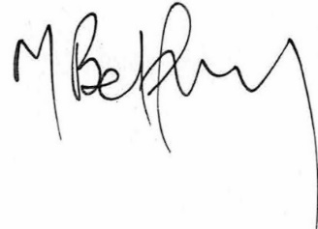

President

Margaret Belfrage

Treasurer 

Geoff McDonald

Date of Committee resolution: 19th September 2024

# Financial Report 2023-24

Geoff McDonald, Treasurer

The Financial Report of Portarlington Neighbourhood House Inc. for the financial year 2023-24 is on the following pages and includes:

* the Balance Sheet
* Profit and Loss Statement and
* Grants, Sponsorship and Donations Report.

**Summary**

* Total equity for the year 2023-24 was $**192,474.10** compared with $157,499.72 in 2022-23
* Total income for the year 2023-24 was **$202,839.71**, and total expenses **$167,865.33**

(2022-23 total income was $187,342.83 and total expenses $215,216.55)

* PNH achieved an operational surplus for 2023-24 of **$34,974.38** compared with a deficit of $27,873.94for 2022-23.
* A total of $13,700 was received via grant funding in 2023-24 and $4,500 received as donations.
* $1,645.71 of grant funds received in 2023-24, has not been used and acquitted, hence is shown as a liability (grant funds not used must be returned)
* $1872.7 of the sponsorship funds for the PNH Playgroup allow this activity to run for another year or so, is shown in a holding account under the Balance Sheet.
* PNH received $1,500 in donations for activities and events in general - part of the Profit & Loss Statement
* PNH also received many donations in-kind (page 8)

**Please NOTE:**

1. Due to careful management, income is higher than the previous year and expenses are considerably lower.
2. Activity & Event venue costs are not represented in the Profit & Loss Statement. This is due to a dispute with CoGG over utility fees for our 60-hour lease agreement. An overpayment was made in 2022-23 and our account has been in credit. A 3 year agreement has been made with CoGG for fixed utility fees commencing in 2024-25. The total annual venue costs will be about $12,000 depending on venue costs that are not part of the 60-hour lease agreement.

If we had paid the venue costs in 2023-24, then the **operational surplus would be about $22-23K.**

1. The statement of liabilities does not include pre-paid activity coupons not yet redeemed. The cost of calculating this liability is too high compared to the risk of being insolvent. In the event of PNH heading towards wind-up, this liability is about $2K and refunds could be made.
2. Grant funds have been moved from the Profit and Loss Statement to the Balance Sheet as any grant funds not used must be returned. A separate report for grants is included in this report.
3. The Committee has estimated that $150K should be held as part of the Risk Plan Contingency. This would cover contingencies, such DFFH reducing or ceasing funding for Neighbourhood Houses, or PNH requiring emergency accommodation.
4. Use of the surplus funds (considered to be about $22K per annum based on 2023-24 data) will be decided as part of a planning process later in 2024. Members will be engaged in these decisions.

## Balance Sheet

|  |  |  |  |
| --- | --- | --- | --- |
|  | **Account** | **30 June 2024** | **30 June 2023** |
|  |  |  |  |
| **Assets** | |  |  |
|  | **Bank** |  |  |
|  | Debit Card PNH | 300.91 | 541.29 |
|  | Port Neighbourhood House | 20,751.03 | 28,364.39 |
|  | SAVINGS Portarlington Neighbourhood House | 30,359.73 | 0.00 |
|  | TD Bendigo Bank | 141,760.84 | 135,453.67 |
|  | **Total Bank** | **193,172.51** | **164,359.35** |
|  | **Current Assets** |  |  |
|  | Accounts Receivable | 243.00 | 815.00 |
|  | Float | 200.00 | 200.00 |
|  | **Total Current Assets** | **443.00** | **1,015.00** |
|  | **Fixed Assets** |  |  |
|  | Computer Equipment | 497.00 | 497.00 |
|  | Equipment | 4,000.00 | 4,000.00 |
|  | **Total Fixed Assets** | **4,497.00** | **4,497.00** |
| **Total Assets** |  | **198,112.51** | **169,871.35** |
|  |  |  |  |
| **Liabilities** | |  |  |
|  | **Current Liabilities** |  |  |
|  | Accounts Payable | 420.00 | 2,534.59 |
|  | Grants Account | 1,212.83 | 0.00 |
|  | Superannuation Payable | 0.00 | 3,056.55 |
|  | Historical Adjustment | 0.00 | 871.05 |
|  | PAYG Withholdings Payable | 0.00 | 5,658.00 |
|  |  |  |  |
|  | HOLDING ACCOUNTS |  |  |
|  | Bellarine Big Band Funds Holding Account | 29.76 | 0.00 |
|  | Garden Club Funds Holding Account | 1,950.08 | 251.30 |
|  | Harmonica Group Funds Holding Account | 152.88 | 0.00 |
|  | PNH Playgroup Funds Holding Account | 1,872.72 | 0.00 |
|  | Rounding | 0.14 | 0.14 |
|  | **Total Current Liabilities** | **5,638.41** | **12,371.63** |
| **Total Liabilities** |  | **5,638.41** | **12,371.63** |
|  |  |  |  |
|  | **Net Assets** | **192,474.10** | **157,499.72** |
|  |  |  |  |
| **Equity** | |  |  |
|  | Current Year Earnings | 34,974.38 | (27,765.05) |
|  | Retained Earnings | 157,499.72 | 185,264.77 |
|  |  |  |  |
| **Total Equity** |  | **192,474.10** | **157,499.72** |

## Profit & Loss Statement

**For the year ended 30 June 2024**

|  |  |  |  |  |  |
| --- | --- | --- | --- | --- | --- |
|  |  |  | **Income** | **Expenses** | **Surplus** |
| **TOTALS for 2023-24** |  |  | **202,839.71** | **167,865.33** | **33,923.14** |
|  |  |  |  |  |  |
|  |  |  | Income | Expenses | Surplus |
| **Activities (members only)** |  |  | **60,827.64** | **9,538.01** | **50,869.63** |
| Activity Income/Coupons/Sponsorship | 60,827.64 |  |  |  |  |
| Activity venue costs |  | (0.00) |  |  |  |
| Activities equipment & resources |  | (1,677.98) |  |  |  |
| Activity Facilitator Costs |  | (7,243.71) |  |  |  |
| Activity kitchen supplies |  | (465.15) |  |  |  |
| Activities IT Subscriptions |  | (386.77) |  |  |  |
| Activities non IT subscriptions |  | (70.00) |  |  |  |
| CoGG Lease fee (60hr lease) |  | (114.40) |  |  |  |
|  |  |  |  |  |  |
|  |  |  |  |  |  |
|  |  |  |  |  |  |
|  |  |  | Income | Expenses | Surplus |
| **Events (open to non-members)** |  |  | **24,587.30** | **9,921.60** | **14,665.70** |
| Event Income | 23,052.30 |  |  |  |  |
| Event raffle income | 1,535.00 |  |  |  |  |
| Event venue costs |  | (0.00) |  |  |  |
| Event Advertising |  | (193.72) |  |  |  |
| Event Catering |  | (5,103.78) |  |  |  |
| Event entertainers |  | (1,135.00) |  |  |  |
| Event Equipment & Resources |  | (582.86) |  |  |  |
| Liquor Licence Expenses |  | (372.18) |  |  |  |
| Event entry fees, subscriptions & permits |  | 0 |  |  |  |
| Event Travel |  | (2534.06) |  |  |  |
|  |  |  |  |  |  |
|  |  |  |  |  |  |
|  |  |  | Income | Expenses | Surplus |
| **Other Business** |  |  | **1,635.87** | **587.55** | **1,048.32** |
| Other Business income (sales) | 1,176.87 |  |  |  |  |
| Other Business donations/gifts/sponsorship | 154.00 |  |  |  |  |
| Film Society Administration fees to PNH | 305.00 |  |  |  |  |
| General repairs & maintenance |  | (421.05) |  |  |  |
| Other Business Equipment & Resources |  | (166.50) |  |  |  |
|  |  |  |  |  |  |
|  |  |  | Income | Expenses | Loss |
| **Program Manager Employee Costs** |  |  | **96,914.001** | **100,771.36** | **(3,857.36)** |
| DFFH Funding | 96,914.00 |  |  |  |  |
| Program Manager employee costs  (wages, Superannuation, Workcover, training, travel, etc.) |  | (100,771.36) |  |  |  |
|  |  |  |  |  |  |
|  |  |  |  |  |  |

Profit & Loss Statement for the year ended 30 June 2024-continued

|  |  |  |  |  |  |
| --- | --- | --- | --- | --- | --- |
|  |  |  | Income | Expenses | Loss |
| **Office/Administration** |  |  | **12,350.00** | **40,919.55** | **-28,569.55** |
| Memberships | 12,350.00 |  |  |  |  |
| Admin Assistant employee costs |  | (31,187.13) |  |  |  |
| Gifts |  | (238.37) |  |  |  |
| Phone |  | (2,593.93) |  |  |  |
| Computer Hardware/Software |  | (1,500.00) |  |  |  |
| IT support & maintenance |  | (415.00) |  |  |  |
| Office Stationery Supplies |  | (680.77) |  |  |  |
| Postage |  | (184.50) |  |  |  |
| Printing/ Copying |  | (2,359.38) |  |  |  |
| Office IT subscriptions |  | (1,691.47) |  |  |  |
| Office subscriptions non IT |  | (69.00) |  |  |  |
|  |  |  |  |  |  |
|  |  |  |  |  |  |
|  |  |  |  |  |  |
|  |  |  |  |  |  |
|  |  |  | Income | Expenses | Surplus |
| **Governance** |  |  | **6,524.90** | **5,707.26** | **817.64** |
| Governance donation/gifts/sponsorship | 8.00 |  |  |  |  |
| Interest Earned | 6,516.90 |  |  |  |  |
| Accounting/financial advice |  | 0 |  |  |  |
| Bank Charges |  | (498.22) |  |  |  |
| Insurance All |  | (1,319.57) |  |  |  |
| Committee development & planning |  | (209.30) |  |  |  |
| Governance catering, gifts |  | (968.25) |  |  |  |
| Governance IT Subscriptions |  | (2,063.52) |  |  |  |
| Committee non IT subscriptions |  | (678.40) |  |  |  |
|  |  |  |  |  |  |

## Summary of profit & loss (operational surplus)

|  |  |  |
| --- | --- | --- |
| Surplus from Member Activities | 50,869.63 |  |
| Surplus from Community Events | 14,665.70 |  |
| Surplus from Other Business | 1,048.32 | Note NO venue costs paid |
| **Gross Profit from operations** | **66,583.65** | in 2023-24 |

|  |  |
| --- | --- |
| Office overheads | **-28,569.55** |
| Governance overheads | **817.64** |
| **Overhead costs (excluding activity & event costs)** | -27,751.91 |

|  |  |
| --- | --- |
| **Gross Profit from operations** | 66,583.65 |
| **Overhead costs (excluding activity & event costs)** | -28,751.91 |
| **Net Surplus from operations (excluding Program Manager costs)** | **38,381.74** |

|  |  |  |
| --- | --- | --- |
| Net Surplus from operations (excluding Program Manager costs) | 38,381.74 | Operating Surplus |
| Loss from Program Manager costs/DFFH funding | (3,857.36) | would be about $22-23K if |
| **TOTAL Net Surplus** | **34,974.38** | venue costs paid |
|  |  | if venue costs paid |

## Grants, Sponsorship & Donations

|  |  |  |  |
| --- | --- | --- | --- |
| **Grants account as at 30th June 2024** | **Credit** | **Debit** | **Balance** |
| CoGG Neighbourhood House Grant - equipment | 2,500.00 | 2,500.00 | 0.00 |
| CoGG Neighbourhood House Grant - governance | 2,500.00 | 854.29 | 1,645.71 |
| CoGG Christmas in the Community Grant | 4,400.00 | 4,400.00 | 0.00 |
| CoGG Positive Ageing grant (Lawn Bowls Event) | 1,000.00 | 1,000.00 | 0.00 |
| Geelong Community Foundation (Harmonica Band equipment) | 1,500.00 | 1,500.00 | 0.00 |
| CoGG Healthy & Connected Communities Equipment Grant (PC upgrades) | 1,800.00 | 1,800.00 | 0.00 |
| **Totals** | **13,700.00** | **12,054.29** | **1,645.71** |

* Balance in liabilities

In 2023-24, PNH submitted 2 grant applications that were unsuccessful: Australia Post Community Grant 2023; and Portarlington Golf Club Community Fund 2024. All grants have been acquitted successfully.

So far in 2024-25, PNH has submitted 8 grant applications. This represents a lot of time consuming work.

|  |  |  |  |
| --- | --- | --- | --- |
| **Sponsorship** | **Credit** | **Debit** | **Balance** |
| Lions Club (for PNH Playgroup) | 500 | 500 | 0.00 |
| The Port Report (for PNH Playgroup - in Holding Account) | 2000 | 127.28 | 1872.72 |
|  |  |  |  |
| Hallettstone Memorials (events account) | 500 |  |  |
| Heenan’s Building Service (events account) | 500 |  |  |
| Lime Healthcare (activities account) | 500 |  |  |
| **Totals** | **4,500** |  |  |

PNH is looking towards sponsorship as an alternative funding source.

**Donations of goods or in-kind support**

PNH is fortunate to be supported by many businesses, mostly for assistance with advertising and providing goods for raffles. Thank you to the following businesses.

* Donation of goods for raffles
  + Van Loons Nursery
  + Celebrations Portarlington
  + Portarlington Bakery
  + Daniel’s Donuts
  + Zero Gravity Health
  + Rutherford Trees
  + Bunnings
* Neville Richards (assistance with billboard advertising)
* Melita Proebstl (My Bookkeeping Solutions) - for services in-kind
* Royal Australian Navy Band (free performance)

# PNH Strategic Performance 2023-24

Margaret Belfrage - President

Rob Sztogryn - Program Manager

Jonathan Harris - General Committee Member, Quality & Performance

Summary 2023-24

Strategic Performance is evaluated against PNH’s five strategic goals (Strategic Plan 2022-26)

At time of writing this report, PNH is about halfway through the Strategic Plan 2022-26.

Results are on-track to achieving this plan.

|  |  |  |
| --- | --- | --- |
| 1. **Membership** | Our membership is growing to better reflect community demographic | **Great Results** due to introduction of PNH Playgroup (page 11) |
| 1. **Program** | Our program is growing to meet the diverse needs of our members and the community | Results are **consistent** with previous years - Member Activity Program not growing but evolving slowly (page 12) |
| 1. **Community Connections** | Our community is growing in awareness and engagement with PNH | **Great results** (page 13) -   * Increase in number & diversity of events * Community Needs Workshop with community leaders to identify community needs |
| 1. **Culture** | Our members are supporting and engaging new ideas through friendships and connections | **Progressing** (page 14) -   * Maintaining PNH volunteer participation rate * New event leaders emerging |
| 1. **Governance** | Our governance and administration practices are grounded in accountability, transparency and achievement | **Progressing** - Maintaining focus on documenting policy and now focusing on documenting and improving operational processes - lots of improvements (page 15) |

Highlights 2023-4

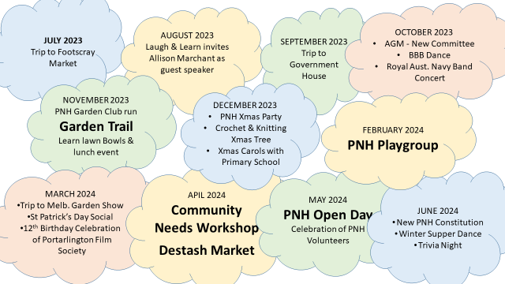

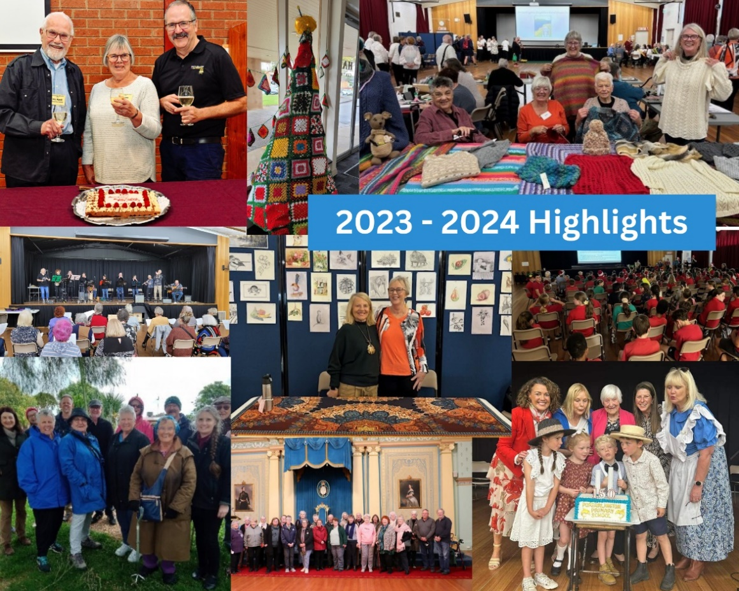

## 1 Membership

*Strategic Goal - Our membership is growing to better reflect community demographics*

*Success demonstrated by: the total number of active members being at least 7.5% of the total 3223 population; and PNH membership reflecting community demographics (using census data as a guide) for numbers in each age demographic and median age.*

GREAT RESULTS!!

#### PNH Performance 2023-24

Committee expected a membership of about 500 in 2024 due to increase of membership fees, without loss of participation numbers (refer to participation data, Table 3). This was achieved (Table 1).PNH membership is very healthy.

Table 1: **membership data**

|  |  |  |  |
| --- | --- | --- | --- |
|  | 2022 | 2023 | 2024 |
| Number of members as at 31st December |  | 760 |  |
| Number of members as at 30th June | 563 | 682 | 570 |
| Median age members | 68 | 70 | 59 |

*Includes Associate members (and juniors)*

PNH membership is about 15% of the 3223 population. PNH is the largest adult member club in Portarlington (other than the Golf Club).

At this stage we cannot measure the percentage of active vs inactive members but expect that most members are currently active. PNH cannot service 700 members in retirement years due to lack of facility space during peak times. The median age of members is now similar to the median age of 3223 residents (Census data 2021) (Table 1).

Membership by age demographics improved in 2023-24 due to establishing the PNH Playgroup.

Table 2: **membership by age demographic**

|  |  |  |  |  |
| --- | --- | --- | --- | --- |
|  | % of total population 2021 (Census data) | Target Participation rate for 600 members | **Approximate number of members July 2023** | **Approximate number of members July 2024** |
| 0-4 years | 2.9 | 17 | 0 | 41 |
| 5-9 years | 3.6 | 21 | 0 | 2 |
| 10-19 years | 7.2 | 43 | 3 | 1 |
| 20-29 years | 6.2 | 37 | 8 | 5 |
| 30-39 years | 7.3 | 44 | 6 | 13 |
| 40-49 years | 8.9 | 53 | 5 | 15 |
| 50-59 years | 14.2 | 85 | 33 | 15 |
| 60-69 years | 23.7 | 142 | 220 | 144 |
| 70-79 years | 18.6 | 112 | 305 | 245 |
| 80 > years | 7.5 | 45 | 102 | 89 |
| **Total membership** |  |  | **682** | **570** |

Note:

* An increase in pre-school years, and 30-40 year olds (their parents) due to PNH Playgroup.
* The participation rate is reasonably consistent (Table 3) indicating that many of the members in 2023-24 were not very active. A drop in retiree membership is mostly due PNH being unable to provide more activities (increasing Program hours) across peak times in the venue.

## 2 Member Activities

*Strategic Goal - Our program is growing to meet the diverse needs of our members and the community*

*Success demonstrated by the PNH Program of Member Activities: aligning with purpose/mission and strategic direction (e.g. activities for all age demographics); meeting member need and maximising member participation (demonstrated by participation rate); providing diversity; being safe & accessible; and being cost efficient (financial data).*

Results consistent with previous year

#### PNH Performance 2022-23 - Activities

PNH Member Activities are open to members only.

Activity fees were raised in 2023 to meet rising costs. Gross profit from member activities was much higher in 2023-24 than 2022-23 (Finance data - about $35K compared to about $15K when adjusting for CoGG utility fees). The coupon system continues to be popular for members to pay for activities. The participation rate in 2023-24 is similar to 2022-23 (Table 3), and the number of program hours delivered in also about the same in 2023-24 compared to 2022-23.

#### Member Activities in 2023-24

**Arts & Crafts**

Card Making

Creative Art

Crochet & Knitting

Drawing & Sketching

Getting creative with mosaics

Painting for Fun

Tuesday Art Group

Sewing

Cartoon Drawing

**Literature & Learning**

Arm Chair Travel

Back-to-school for seniors

Book Club

Fiction Fiddlers

Main Street Writers

Non-fiction Writers

Philosophy Café

**Dance & Music**

Julie Blues Harmonica

Dancing in the Dark

Guitar

Harmonica Band

Line Dancing - Next Step

Line Dancing for beginners

Sing-a-long

Bellarine Big Band

Ukulele

**Fitness & Relaxation**

Indoor Bowls

Power Walking

Strength & Stretching

Tai Chi

Zumba

Yoga

Meditation

**Card & Games**

500 Card Game

Bolivia

Chess

Mahjong

Local Legacy

Darts

**Nature & Environment**

Bird Watching & Nature Ramble

Gard Club

**Portarlington Film Society** (PNH partner organisation)

#### New Member Activities in 2023-24

PNH Playgroup

Free Hearing Tests conducted at PNH

Macrame

#### Activities that closed in 2023-24

Local Legacy

Julie Blues Harmonica

Cartoon Drawing

Indoor Bowls

Table 3: **Number of participations per year**

|  |  |  |
| --- | --- | --- |
|  | 2022-23 | 2023-24 |
| *Number of participations per year (total) | 12,600 | 13,000 |

*includes number of participants at activities, events and in community projects - members and non-members

*a participant is a walk through the door, e.g. if a member attends 6 PNH sessions per month, that is 6 participations per month

### Facilities Update

As members are aware, the Parks Hall facility is not suitable for PNH. PNH is at capacity during peak times and cannot expand the Program to meet the needs of members. CoGG has not progressed work to alleviate this problem as recommended in the 2023 CoGG Portarlington Facilities Scoping Study.

## 3 Community Connections

*Strategic Goal - Our community is growing in awareness and engagement with PNH*

*Success demonstrated by: - increased community awareness of PNH and increased engagement indicated by the number of non-member participants in Community Events; marketing KPIs such as Facebook hits; and anecdotal evidence.*

GREAT RESULTS!! Community is engaging more with PNH-in different ways.

Table 4: **Estimate of number of non-member participants at PNH**

|  |  |  |
| --- | --- | --- |
|  | 2022-23 | 2023-24 |
| Approximate number of non-member participants per year (community connections) | (no data) | *400 |

*a non-member participant is an attendance at a PNH Community Event. *data not accurate as data collection methods still developing.

### Community Events

What’s New in 2023-24?

* Highlights are many such as: Destash Market; Garden Trail; PNH Open Day and band performances. Congratulations - member contribution is fantastic!!
* The number of Community Events for 2023-24 was **35 compared to 11** in 2022-23 (Table 5)
* The number of members engaged in delivering events and the diversity of community events greatly increased.
* The number of non-members engaging with PNH via Community Events has increased.

Table 5: **Number of PNH Community Events**

|  |  |  |
| --- | --- | --- |
|  | 2022-23 | 2023-24 |
| Number of Community events | 11 (data not complete) | 35 |

Events in 2023-24 included:

* social nights
* trips
* concerts & dance nights
* market days
* Destash Market
* PNH Open Day
* Garden Trail (PNH Garden Club)
* Sip & SumE
* Trivia Night
* Lawn Bowling
* Performances by Portarlington Harmonica Band and Bellarine Big Band
* Repair cafe

#### PNH Performance 2022-23 - Facebook hits.

|  |  |
| --- | --- |
|  | Facebook hits peaked in February due to the PNH Playgroup introduction.  Number of Facebook Followers has steadily increased from 160 to 593 and growing |

### Community Projects

Meeting community needs is an obligations under our DFFH agreement. A PNH Community Needs Workshop in April 2023 was attended by representatives from: GG&Q Mental Health Wellbeing Local; BCH Youth Health and Wellbeing; Portarlington Cricket Club; Food Assist 3223; Church By the Bay; Salvation Army; Portarlington/Drysdale Lions Club; and Bellarine Police Unit. Community Projects was added to the PNH Purpose Statement in June 2024. Work in Community Projects is part of PNH Program hours to meet DFFH service agreement.

**Community Projects in 2023-24**

Nov 23 Portarlington Toy Library charity project -members sewed carry bags, materials provided by Lions Club.

April 24 PNH Community Needs Workshop (projects will follow)

## 4 Culture

*Strategic Goal - Our members are supporting and engaging new ideas through friendships and connections*

*Success demonstrated by: Members and staff comply with the values and desired behaviours as found in the Code of Conduct Policy, demonstrated by rate of volunteering. PNH values - Integrity, sense of community, respect. PNH desired behaviours - members are engaged, friendly and supportive.*

Progressing!

PNH’s biggest cultural asset is volunteering. About 10% of our members volunteer at PNH. This is evidence of member engagement.

The aim in 2023-24 was to encourage volunteers to work in new roles created to reduce Coordinator hours in administration, and to focus on program development. This aim was not fully achieved.

However, a number of new event managers emerged in 2023-24, providing a significant increase in our event program, adding diversity to the program and more opportunity for PNH to engage with the community - this is good progress.

**Thank you for every volunteer hour!!**

Volunteers work on the Committee, or in operations as Office Assistants, Activity Facilitators, or in Community Events and Handyman/Maintenance roles

Members are also engaged in decision making, e.g. members were engaged in the upgrade of the PNH Constitution to meet ACNC regulations and maintain charitable status.

Table 6: **Volunteer Data**

|  |  |  |  |  |
| --- | --- | --- | --- | --- |
|  | * Number of volunteers in significant roles | **Number of significant volunteer roles | Total volunteer hours | estimated $ worth |
| **2022-23** | 55 | 73 | 4100 | >$245K |
| **2023-24** | 55 | >70 | 4291 | >$257K |

*\*Some members volunteer in more than 1 role*

*\*\*Many members volunteer ad hoc in a variety of roles as required (not included in the count)*

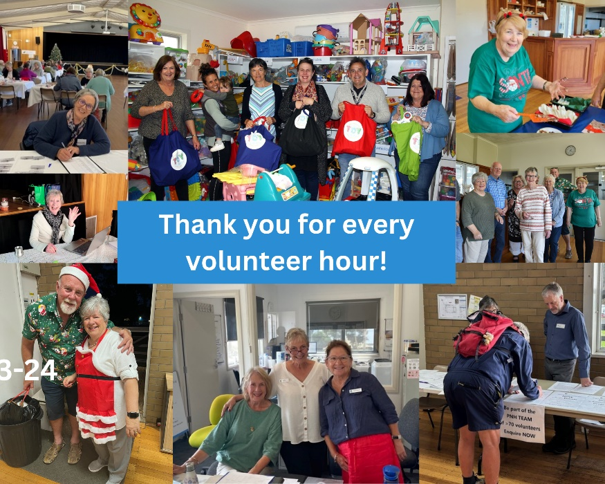

## 5 Governance & Adminisration

*Strategic Goal - Our governance and administration practices are grounded in accountability, transparency and achievement*

*Success demonstrated by: governance being transparent and members engaged in decisions; achieving desired performance results; continually improving governance and administrative practices to reflect a modern, flexible organization; information and communication to members will be accessible, timely, accurate and meet needs of members; and no serious incidents.*

Progressing!

The work of the Committee in managing compliance and performance is considerable and complex. PNH must comply with a vast array of regulations. Since the last AGM, the Committee introduced portfolio roles for each committee member. This has been very successful, not just because it spreads the committee workload but because new eyes have been across the work, and we have been able to achieve more in developing our governance capability.

A compliance audit was conducted. Committee has been able to dig deeper into our compliance issues to ensure PNH is compliance with regulations and obligations, and operational policy is appropriate.

Progress has been made in data integrity for both financial, operational non-financial data, and for PNH records. Committee has also greatly improved record keeping. Improved data has allowed Committee and management to better analyse and manage performance.

Over the past few years, Committee has developed a process to document operational policy and is now focusing on documenting processes to continually improve administration practices. This is complex work.

One of the greatest challenges to modernization, streamlining and consistency of administrative practices is the connectivity of our systems to reduce paper work and duplication of work.

As PNH moves forward, it may be challenging to our volunteer Office Assistants. The office work will become more technical. The Office Assistants are crucial to PNH success and do a great job. Their input has been essential to continuous improvement and they all do a great job - thanks to all the Office Assistants! PNH communication to members is fantastic- thanks to Kate!

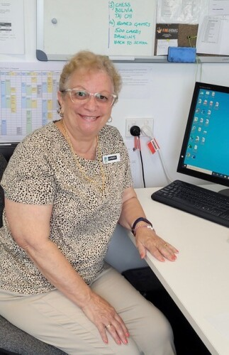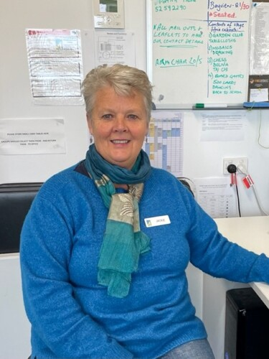

# Minutes

**Minutes for approval**

* Minutes of AGM held on 20th October 2023
* Minutes of Special General Meeting held on 19th June 2023

**PORTARLINGTON NEIGHBOURHOOD HOUSE**

**MINUTES OF ANNUAL GENERAL MEETING 2023**

Date: Friday, 20 October 2023

Venue: Parks Hall

Chairperson: Margaret Belfrage

Secretary: Sue Aspinall

**Attendance**

***Present: Members:*** Dale Afflitto, Eleanor Beasley, Sandy Belcher, Rita Burleigh, Jackie Chase, Brenda Credlin, Ann Cullen, Mary Drew, Juliet Gavens, Jenny Gibbs, Marg Jucker, Diane Kolomeitz, Rob Kolomeitz, Jenny Macaulay, Stella McLean, Mary Micallel, Jackie Milne, Jude Oakley, Margery Painter, John Price, Mirella Price, Jillian Rees, Maree Ryan, Carmen Spiteri, Leonard Spiteri, Steven Stefanou, , Rose Talbot, Jacquie Wissenden, Tony Wissenden

***Staff:*** Rob Sztogryn (Program Manager)

***Apologies:*** Mark Chaffers, Jonathan Harris, Heather Harris

***Proxy Votes Received:*** 10 (as filed)

1. **Opening**

The meeting opened at 5.00pm. Margaret Belfrage, President of the Committee of Management, acknowledged the Wadawurrung, Traditional owners of the land, and welcomed all present.

All documentation for the AGM *(viz. AGM Agenda and Annual Reports 2022-23, Minutes of previous meetings, nomination forms for positions on the Committee of Management, and proxy forms)* had been available on the PNH website for several weeks, and at the office reception, and members had been so informed regularly via the weekly PNH newsletter. Members had also been informed that hard copies of the Annual Reports would not be available at the meeting.

1. **Minutes for approval**

* Minutes of Special General Meeting held on 2 November 2022

Motion: *That the Minutes of the Special General Meeting held on 2 November 2022 be received*.

**Moved:** Di Kolomeitz **Seconded:** Steve Stefanou

* Minutes of Annual General Meeting held on 2 November 2022

Motion: *That the Minutes of the Annual General Meeting held on 2 November 2022 be received*.

**Moved:** Rob Kolomeitz **Seconded:** Steve Stefanou

* Minutes of General Meeting held on 21 June 2023

Motion: *That the Minutes of the General Meeting held on 21 June 2023 be received*.

**Moved:** Steve Stefanou **Seconded:** Ann Cullen

1. **Business Arising from the Minutes:**

* No matters were raised from any of the three sets of Minutes.

1. **Financial Report 2022-23**

The President presented the Financial Report for 2022-23, using a series of slides to show the year’s activity and financial outcome for each of the various cost centres.

The overall situation was:

Total equity: $157,390.83 ($185,264.77 in 2021-22)

Total income: $187,342.61 ($175,220.80 in 2021-22)

Total expenses: $215,216.55 ($189.796.91 in 2021-22)

resulting in a deficit for 2022-23 of $27,873.94 ($14,575.91 in 2021-22).

The meeting was informed:

* that it is hoped the deficit in 2023-24 will be no more than $10k and that by the following year at least a break even situation will be achieved
* that activities are not sufficient to cover office costs
* that PNH remains in dispute with the City of Greater Geelong about excessive charges that have been made for utilities, potentially ever since the move to Parks Hall, and until this is resolved no monthly invoices have been paid since January 2023. Resolution of this dispute in PNH favour would have seen the operational deficit reduced to between $12k and $14k (i.e. similar to 2021-22 financial year), and total equity would be greater.

In response to a question as to why the invoices had been paid it was noted that several factors contributed to this – e.g. lack of detail in the invoices leading to uncertainty as to what was being charged for, and changes at PNH of coordinator and treasurer (both of whom had responsibility for managing the accounts), with no handover in either case. To date, approaches to relevant CoGG personnel seeking more detail and to discuss the overpayment have not progressed any resolution.

The President reported that in order to gain clarity and to finalise the matter, the CoM recently tasked Rob Kolomeitz to meet with the new CoGG CEO and other senior officers; an appointment is being scheduled.

* PNH currently carries the cost of bank charges for credit card payments (approx. $600), but may have to consider a surcharge on all credit card transactions to recoup this.

Motion: *That the Financial Report for 2022-23 be accepted*.

**Moved:** Stella McLean **Seconded:** Rita Burleigh

1. **Annual Strategic Performance**

The President presented the *Annual Strategic Performance report for 2022-23* using a series of slides to illustrate various aspects. Among the matters highlighted or addressed were:

* PNH has a large volunteer base – 78 roles were identified which were filled by 70-80 volunteers in total (including facilitators, office assistants, committee and event personnel, ad hoc volunteer roles). A Neighbourhood Houses Victoria survey estimated that the volunteers contributed 4000 hours of service annually, with an estimated value of $245k. The meeting applauded this significant contribution from PNH volunteers
* PNH has the second largest adult membership of any organisation in Portarlington (Golf Club is the largest), with over 700 members - membership has grown by approximately 100 during the year
* members are predominantly in the upper age groups (over 60% of members are 70 years of age or older)
* the majority of members is not active on a regular basis at PNH
* attention needs to be given to attracting younger cohorts
* the number of activities and activity hours increased during the year, and the efforts of the Program Manager in achieving these results was acknowledged with acclamation. In spite of this however, participation rates and gross profit were not markedly increased
* there is an opportunity to offer more programs during holiday periods; and a play group for preschool children is being actively pursued
* the Committee is trying to engage the membership more actively in decision making – e.g. a meeting was convened to consider the draft *CoGG Portarlington Facilities Scoping Study*, and a number of members engaged in follow up discussions with CoGG and the consultants and/or signed a petition; and another meeting allowed for discussion on an updated PNH strategic action plan
* a great deal of policy development work was undertaken throughout the year.

Motion: *That the Annual Strategic Performance Report for 2022-23 be accepted*.

**Moved:** Steve Stefanou **Seconded:** Jenny Macaulay

The President was thanked, with applause, for the excellent presentation to the meeting of both the Financial and the Strategic Performance reports.

1. **Election of Members to the Committee of Management for 2023-24**

The President vacated the Chair and asked the Returning Officer (Sue Aspinall) to conduct the elections to the Committee of Management for 2023-24.

The Returning Officer informed the meeting that the Committee of Management had determined that for 2023-24 it would comprise 8 members, as follows:

President; Vice-President; Treasurer; Secretary; General Committee members (x4) of whom 1 is designated as Assistant Treasurer.

The positions of Treasurer and Assistant Treasurer were appointed by the committee, and thus there were 6 vacancies to be filled by election.

Nominations had been called for, and closed officially on 13 October 2023. At the closing date two nominations only had been received (for 2 general committee member positions), and thus vacancies remained for the following positions:

President, Vice-President, Secretary, 1 general committee member.

The Returning Officer called for nominations from the floor with the following outcome:

President, **Margaret Belfrage**– nominated by Di Kolomeitz; seconded by Jenny Macaulay

* nomination accepted by Margaret Belfrage, and endorsed by the meeting

Vice-President – no nomination received

Secretary – no nomination received

General Committee members – **Mary Drew and Mark Chaffers** (both of whom had submitted nominations by the official closing date) were declared elected; no nomination received for the 3rd position.

The Returning Officer informed the meeting that **Stella McLean** had been appointed as Assistant Treasurer (4th general committee member) for 2023-24 by the Committee of Management at its October 2023 meeting. The unfilled positions remained vacant, and upon resuming the chair the President urged members to consider nominating, to ensure a vibrant committee.

**Summary - Election and appointment of Committee Members as at 20th October 2023.**

President Margaret Belfrage

Vice-President vacant

Secretary vacant

Treasurer vacant

Assistant Treasurer Stella McLean

General Committee members:

* Mary Drew
* Mark Chaffers
* Vacant

1. **Recognition of 2023 retiring committee members**

* The President acknowledged the contributions of the following committee members who had retired at the meeting, and presented each with a gift:
* Michael Ryan (Vice-President), Sue Aspinall (Secretary), Marg Jucker and Rob Kolomeitz.
* Marg Jucker in particular was thanked for her contribution over many years, and especially for having taken on the role of President through a difficult period for PNH – the move to Parks Hall, two changes in coordinator and the COVID outbreak.

1. The meeting closed at 5.45pm and members were encouraged to attend the Oktoberfest Happy Hour in the Parkview Room.

Minutes - PNH Special General Meeting

19th June 2024, 10am at Parks Hall

Chairperson: Margaret Belfrage, President

Present: Carmen Spiteri, Jenny Gibbs, Mark Chaffers

Apologies: Jacquie Wissenden, Geoff McDonald

Proxies (30): Alan Barlee; Anthony Ahearne; Dale Afflitto; Darryl Lewis; Diane Chaffers; Dianne Lewis; Eleanor Beasley; Franceska Dezelak; Heather Harris; Ian Butler; Jacqui Wissenden; Joan Kelly; Jenny Hall; Joanna Swanson; John Robotham; Jonathan Harris; Judith Barlee; Karen Eller; Katie Hall; Lorraine Stainer; Mary Drew; Maxwell Buchanan; Peter Ashton; Peter Drew; Raili Hilakari; Robyn Farren; Rose Talbot; Sue Aspinall; Sue Moger; Tony Wissenden

Note that 2 proxy submissions were not valid as the proxy was not in attendance.

The President, Margaret Belfrage, opened the meeting at 10.00am.

In the absence of the Secretary, the Chairperson requested that a decision be made regarding a Minute taker. Jenny Gibb moved that Margaret Belfrage act as Minute taker, seconded by Carmen Spiteri, motion carried.

Margaret thanked those present for attending and noted that there was 30 acceptable proxies. A quorum was noted. Margaret noted that although the attendance at the meeting was small, many members contributed to the consultation process as the draft new Constitution was developed, and 30 members submitted a proxy vote to the meeting.

Margaret also explained to the meeting that the purpose statement meet the ACNC regulations for PNH to continue as a registered charity.

The new PNH purpose statement is:

*Portarlington Neighbourhood House Incorporated (PNH) is a public institution*

*which has the charitable purpose of advancing social and public welfare by providing opportunities to:*

·         *learn*

·         *share skills*

·         *bring community members together, and*

·         *work on community projects.*

Margaret pointed out that the addition of “community projects” to the purpose statement was significant, and that PNH was working on several projects to meet community need post a workshop of community leaders to identify potential projects.

**Motion -“to accept proposed changes to the PNH Constitution as communicated to members”.**

**The motion was carried unanimously.**

Margaret thanked those who attended and those who submitted a proxy vote, and thanked Mark Chaffers for his considerable work to ensure that the new Constitution meet ACNC regulations.

Meeting closed at 10.10am.